Which of the following reaction is not accompanied by elimination of a byproduct molecule?
A. addition polymerization
B. condensation polymerization
C. both of these
D. none of these
ANSWER: A

How does the monomer conversion vary at the early stage of step-growth polymerization?
A. faster
B. slower
C. steady
D. none of these
ANSWER: A

The process in which the molecular weight of polymer almost remains unchanged with the progress of reaction is a ___________
A. addition polymerization
B. condensation polymerization
C. copolymerization
D. none of these
ANSWER: A

What does the reaction mixture of addition polymerization contain at any instant of time?
A. full grown polymer molecules
B. unreacted monomer molecules
C. free radical chains and initiators
D. all of these
ANSWER: D

Which of the following polymers contains −C−C− linkages only?
A. addition polymers
B. condensation polymers
C. copolymers
D. none of the these
ANSWER: A

The process in which molecular weight control is achieved by using a stoichiometric imbalance of the reacting functional group is ___________
A. chain growth process
B. step growth process
C. substitution process
D. none of these
ANSWER: B

Which reaction may allow the biphasic interfacial polymerization technique?
A. addition polymerization
B. condensation polymerization
C. both of these
D. none of these
ANSWER: B

Bakelite is the polymer of
A. Formaldehyde and benzene
B. Formaldehyde and Phenol
C. Acetone and benzene
D. Acetone and Phenol
ANSWER: B
Which of the following is the product of condensation polymer?
A. Bakelite
B. Nylon-6, 6
C. PVC
D. Both A & B
ANSWER: D
Nylon-6,6 is an example of
A. Condensation polymer
B. Polyamide
C. Polyester
D. Both A and B
E. Both A and C
ANSWER: D
Nylon-6,6 is produced by
A. Adipic acid and hexamethylene diamine
B. hexanedioic acid and ethane diol
C. Diacid and Diol
D. None of these
ANSWER: A
Which of the following show Addition polymerization?
A. 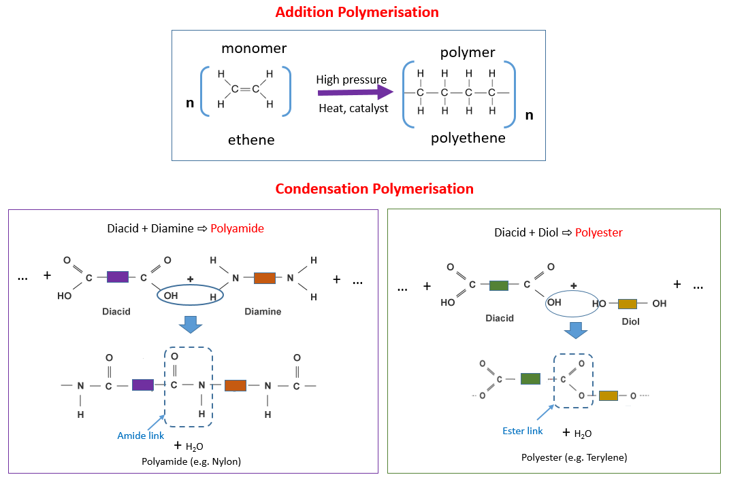
B. 
C. 
D. All of these
ANSWER: C
Select the incorrect statement from the following option.
A. Addition polymerisation requires the presence of double bond in monomer
B. No by-product is formed in addition polymerisation
C. In addition polymerisation, growth of chain is at one active centre
D. In addition polymerisation, polymer MW rises steadily throughout the reaction
ANSWER: D

Select the incorrect statement from the following option.
A. Condensation polymerisation requires two reactive functional groups to be present at both ends of the monomer
B. No by-product is formed in condensation polymerisation
C. In condensation polymerisation, growth of chain occurs at minimum of the two active centres
D. In condensation polymerisation, polymer molecular weight rises steadily throughout the reaction
ANSWER: B

The Ziegler Natta catalyst is formed between
A. Triethyl aluminium and titanium halide
B. Triethyl aluminium and silver halide
C. Triethyl aluminium and platinum halide
D. Triethyl aluminium and carbon halide
ANSWER: A

